Pearson’s correlation analysis

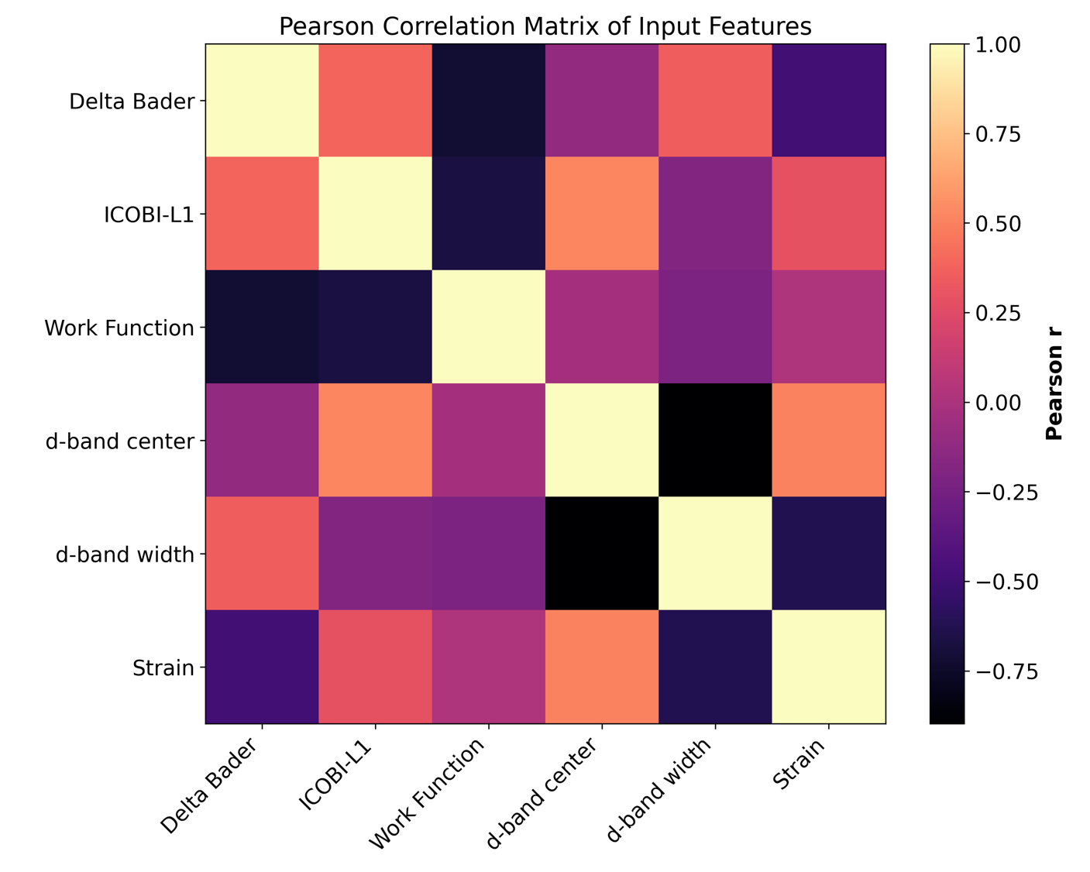
Parity analysis
GPR 6
"Delta Bader", "ICOBI-L1", "Work Function", "d-band center", "d-band width", "Strain"
In-sample: MAE=0.058275, RMSE=0.005428, R2=0.964856
LOOCV: MAE=0.138334, RMSE=0.027733, R2=0.820438

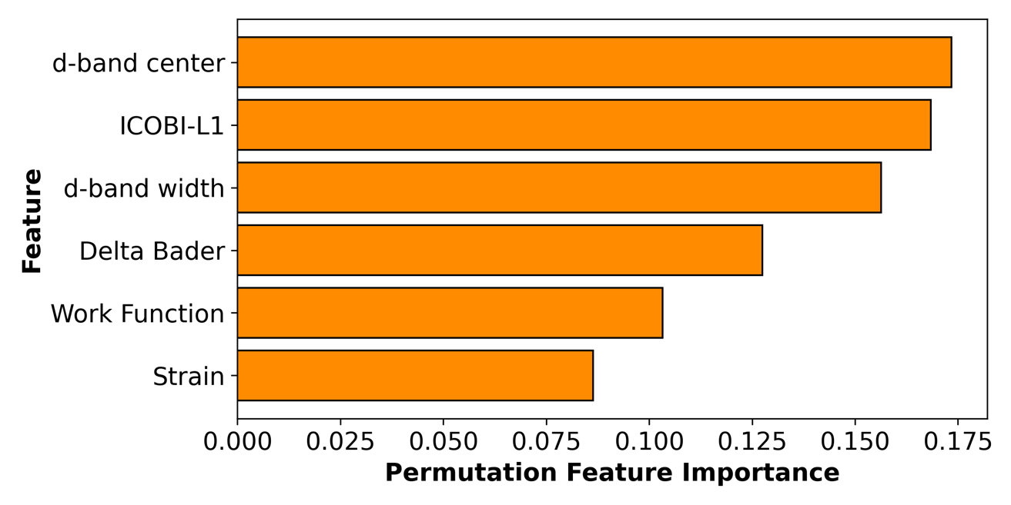
In-sample plot LOOCV plot
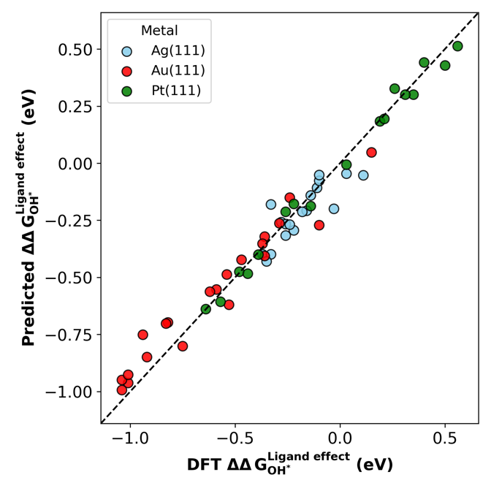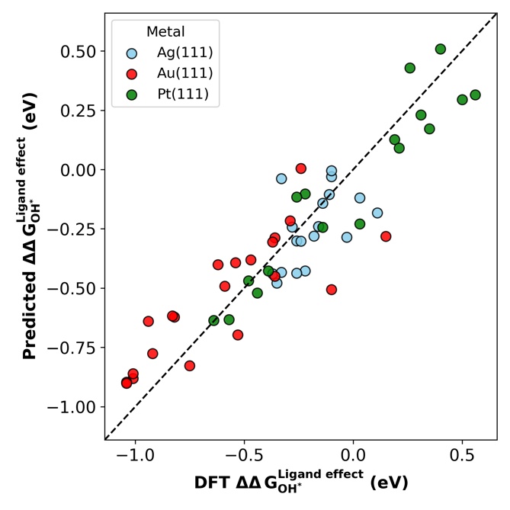

GPR 5
"Delta Bader", "ICOBI-L1", "Work Function", "d-band center", "Strain"
In-sample: MAE=0.060788, RMSE=0.005748, R2=0.962783
LOOCV: MAE=0.141372, RMSE=0.028349, R2=0.816444
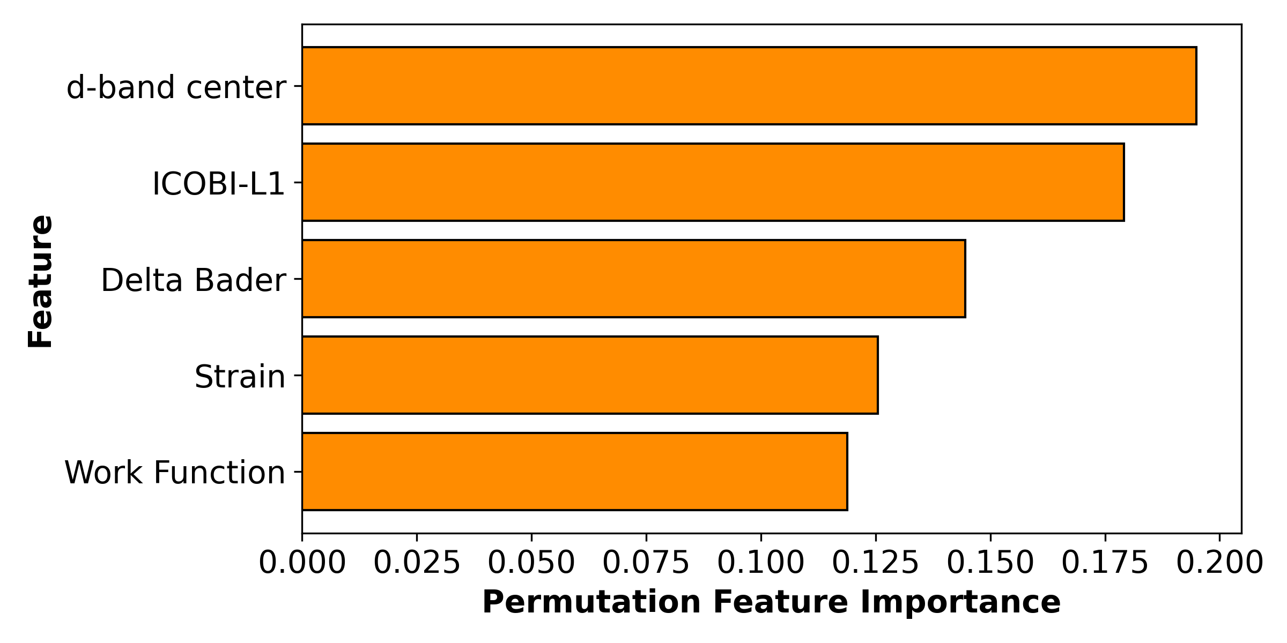
In-sample plot LOOCV plot
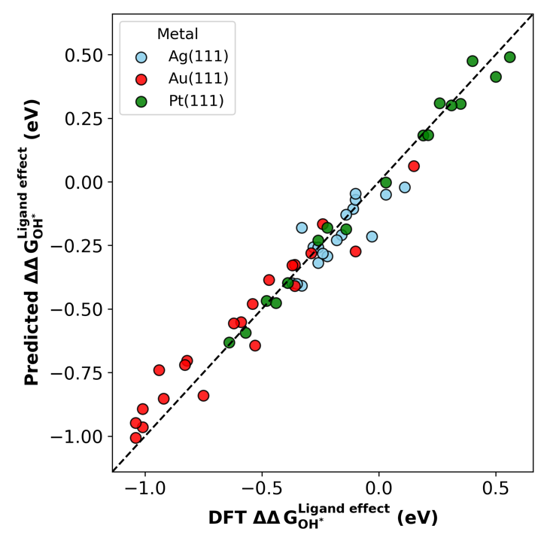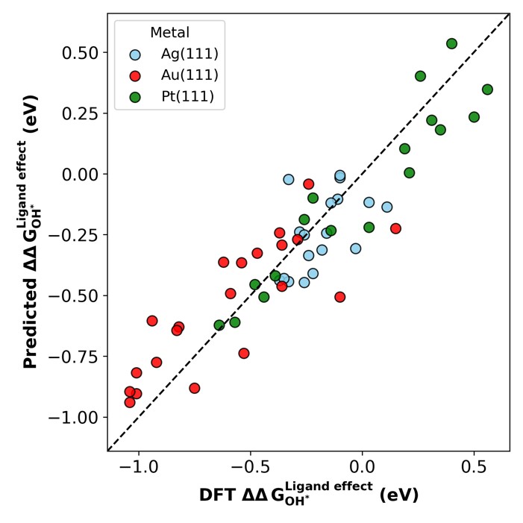

GPR 4 - Strain
"Delta Bader", "ICOBI-L1", "d-band center", "Strain"
In-sample: MAE=0.062160, RMSE=0.006251, R2=0.959529
LOOCV: MAE=0.135603, RMSE=0.027531, R2=0.821745
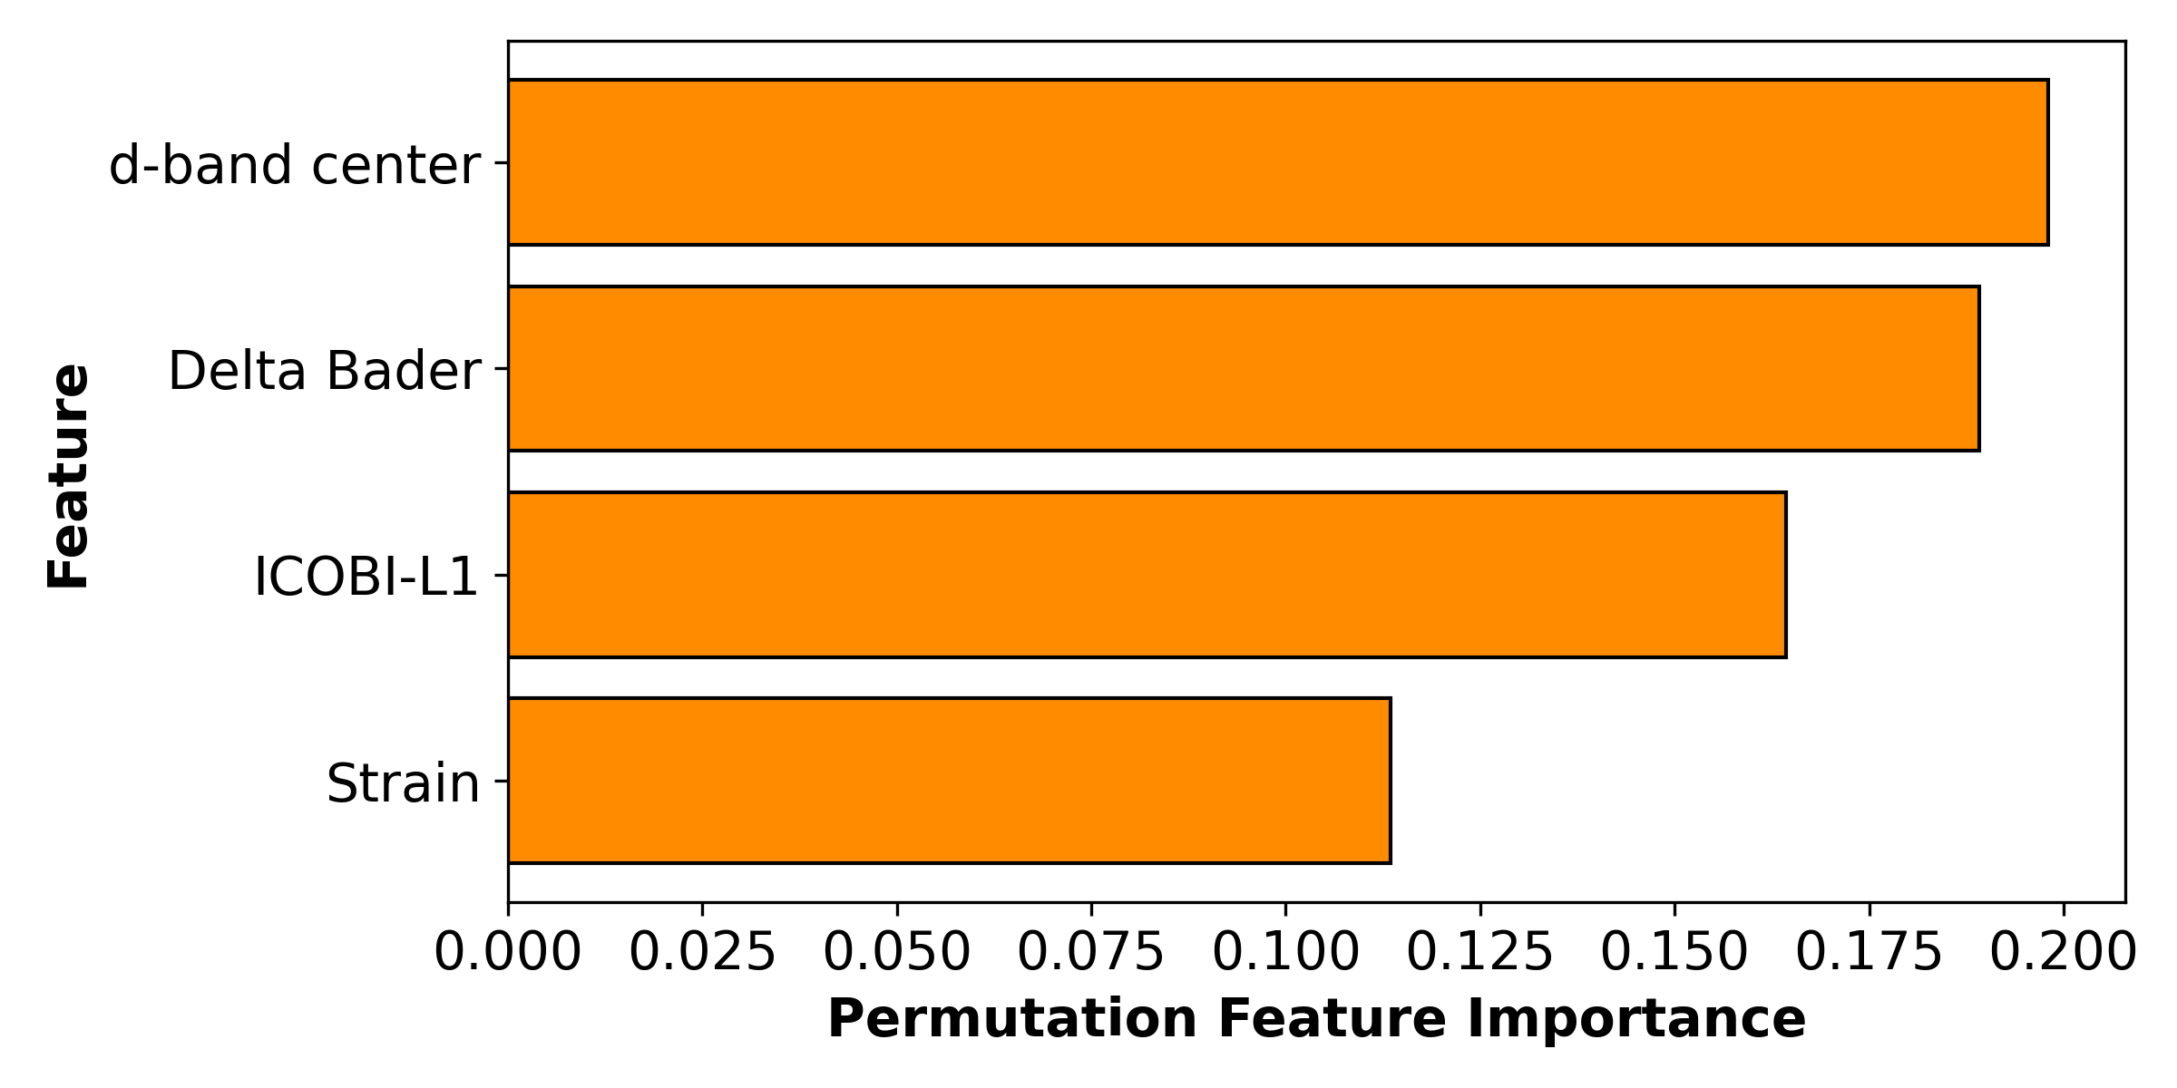
In-sample plot LOOCV plot
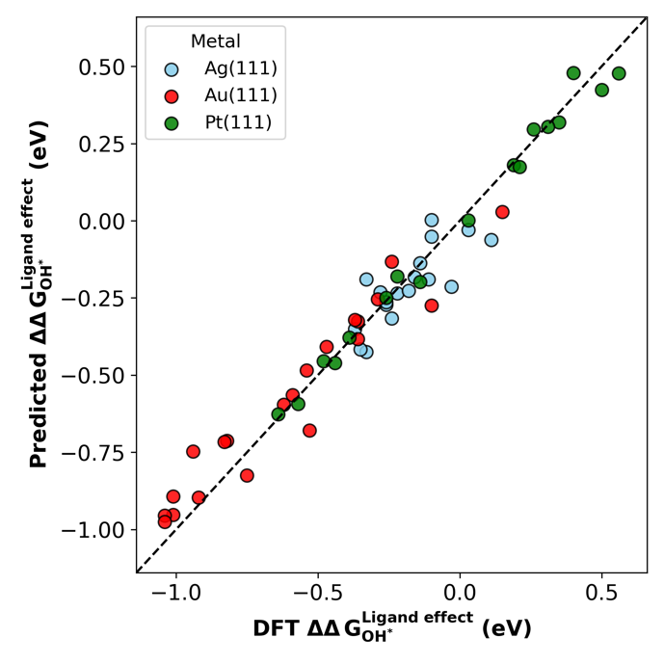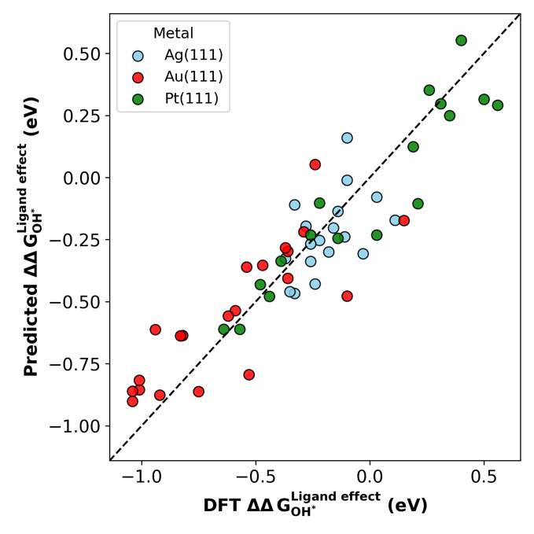

GPR 4 – Work function
"Delta Bader", "ICOBI-L1", "d-band center", " Work Function "
In-sample: MAE=0.054190, RMSE=0.004591, R2=0.970272
LOOCV: MAE=0.169793, RMSE=0.043852, R2=0.716070
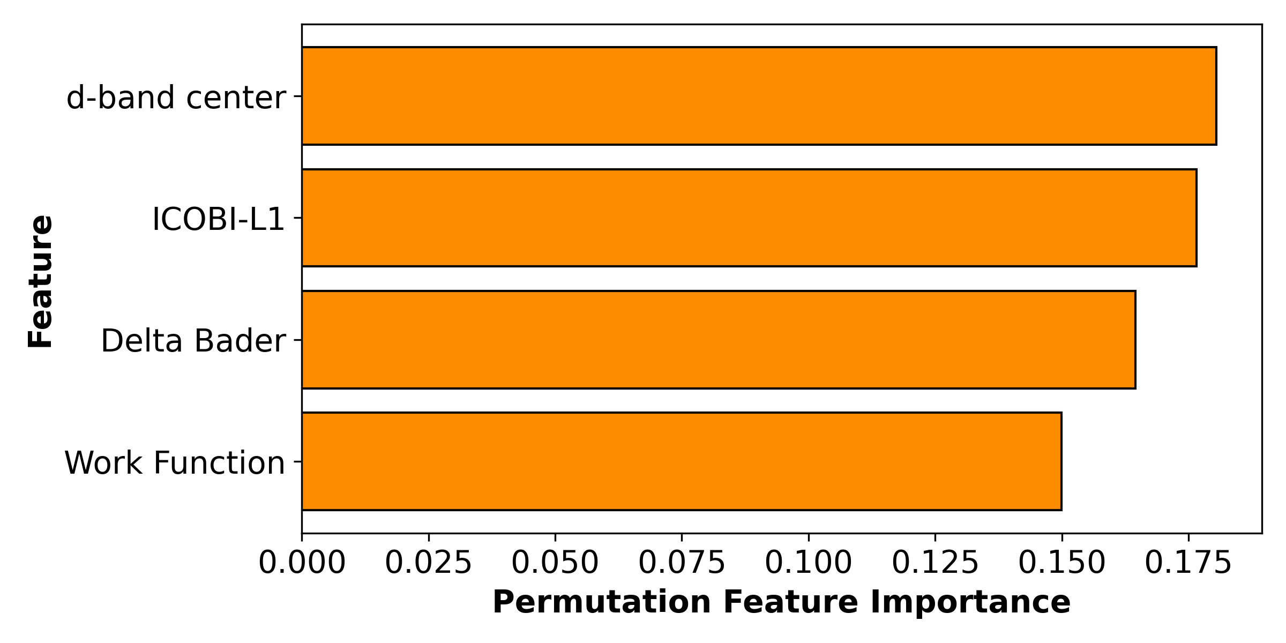
In-sample plot LOOCV plot
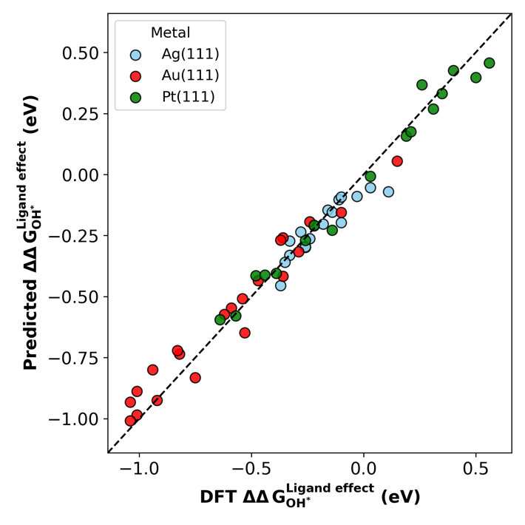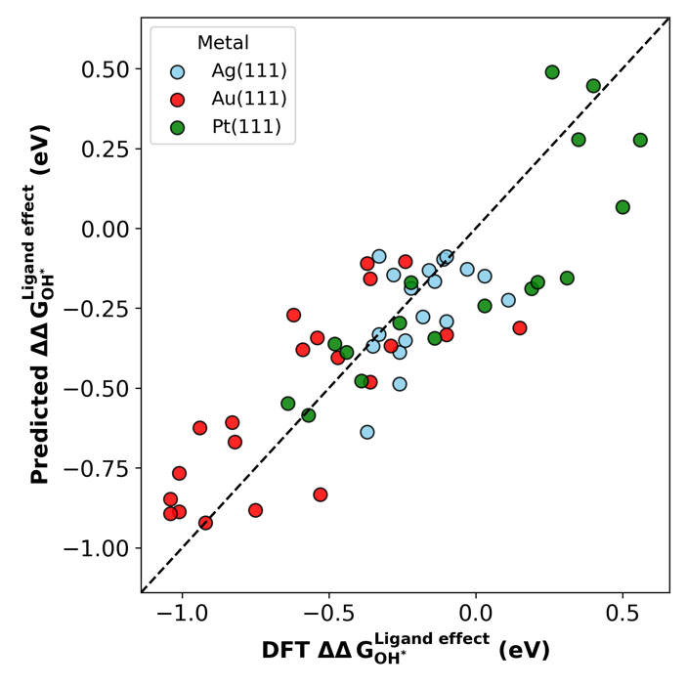

GPR 3 – Bader ICOBI D-band
"Delta Bader", "ICOBI-L1", "d-band center"
In-sample: MAE=0.074565, RMSE=0.010424, R2=0.932507
LOOCV: MAE=0.152109, RMSE=0.038778, R2=0.748920
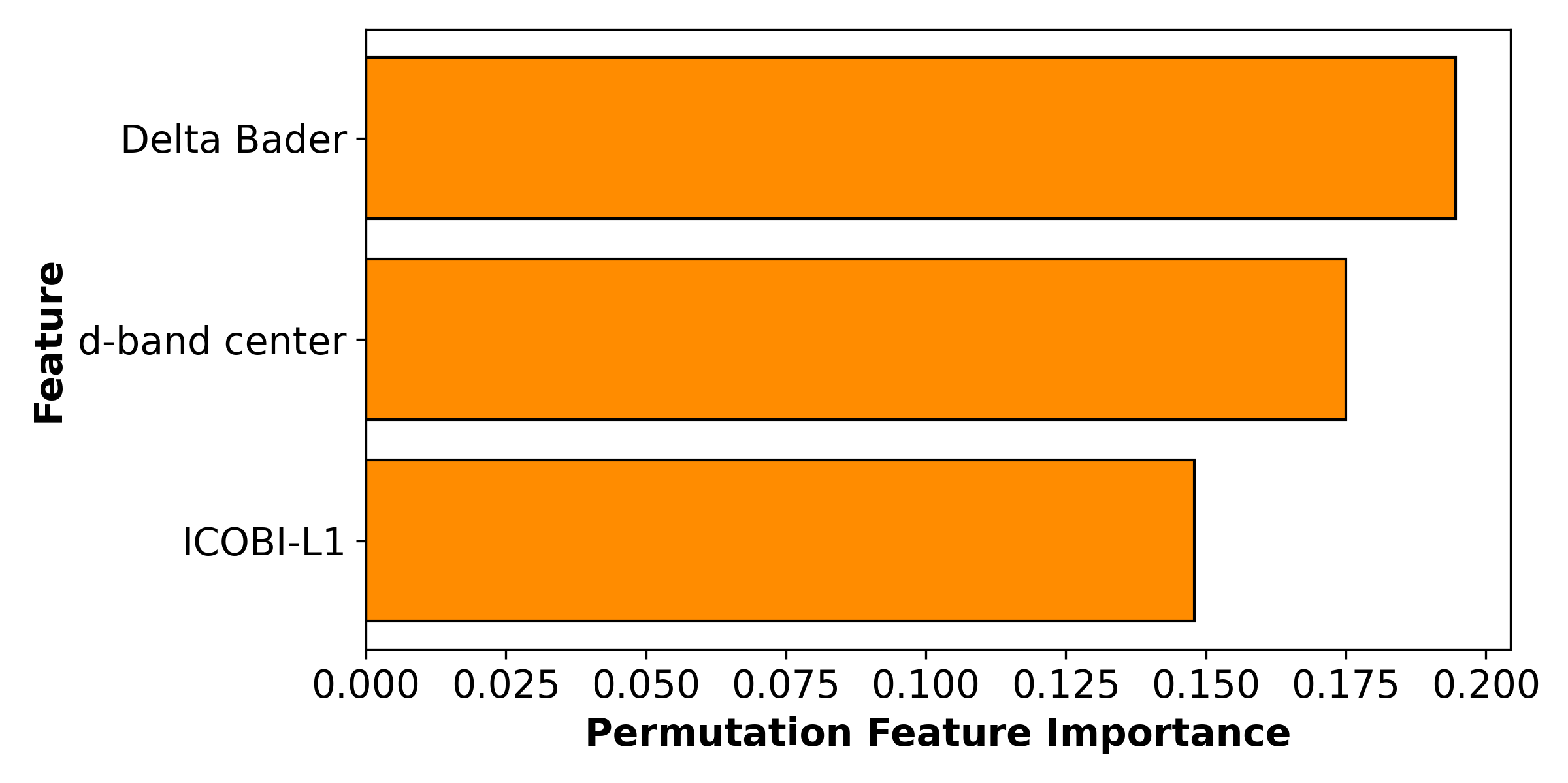
In-sample plot LOOCV plot
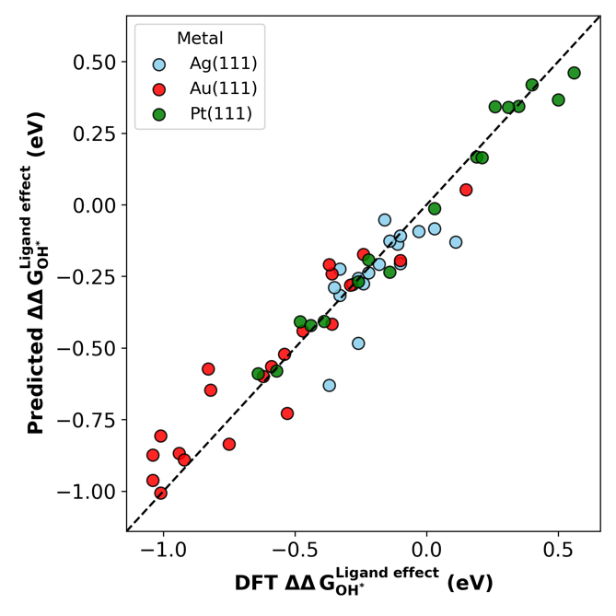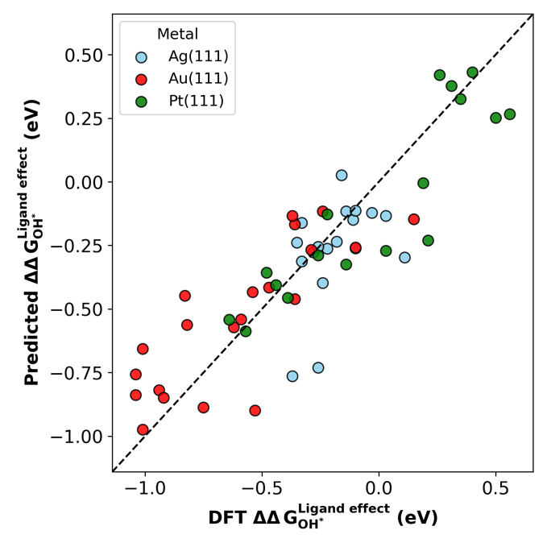

GPR 3 – Bader D-band strain
"Delta Bader", "d-band center", "Strain"
In-sample: MAE=0.034591, RMSE=0.002484, R2=0.983916
LOOCV: MAE=0.226367, RMSE=0.097354, R2=0.369657
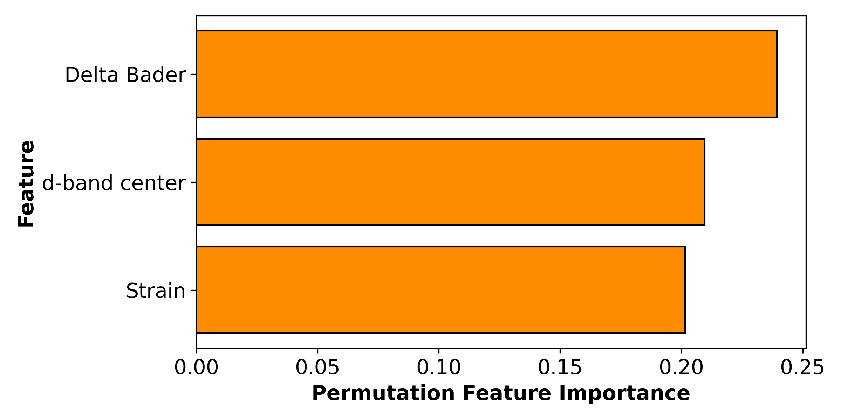
In-sample plot LOOCV plot
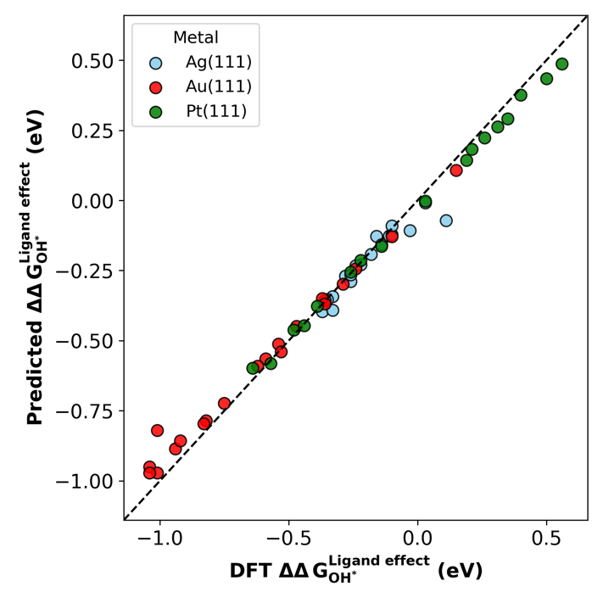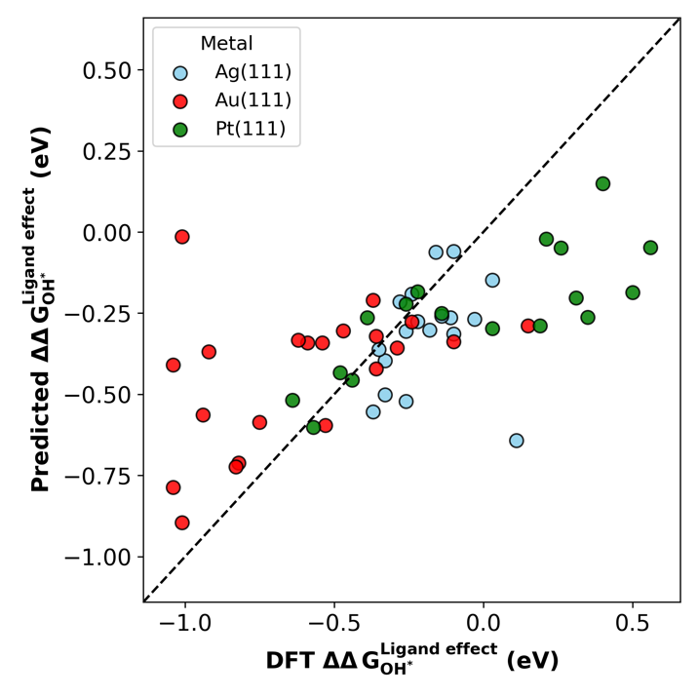

GPR 3 – Bader ICOBI strain
"Delta Bader", "ICOBI-L1", "Strain"
In-sample: MAE=0.047285, RMSE=0.003732, R2=0.975837
LOOCV: MAE=0.232621, RMSE=0.089138, R2=0.422849
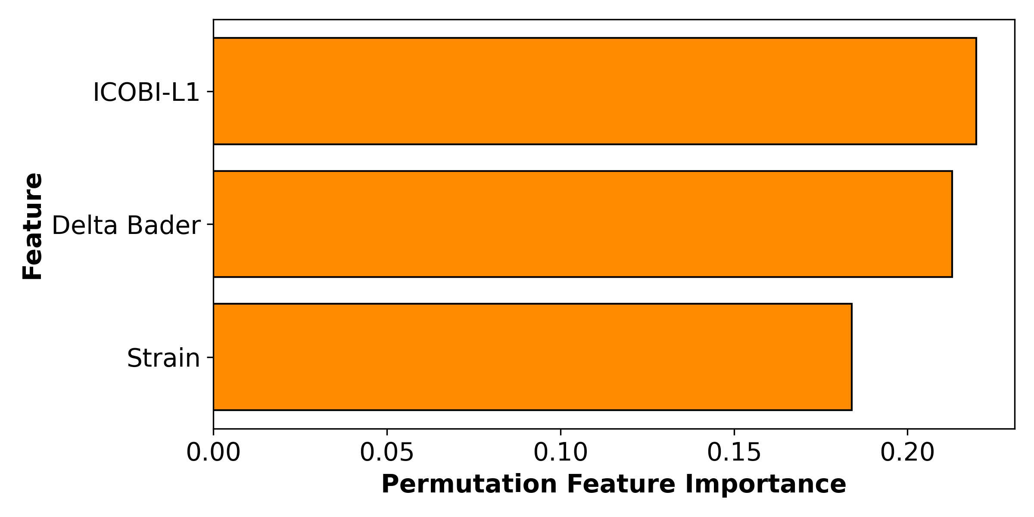
In-sample plot LOOCV plot
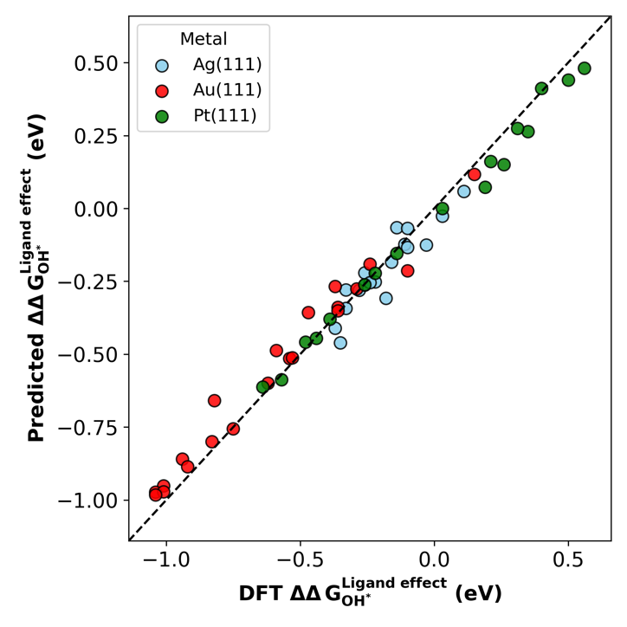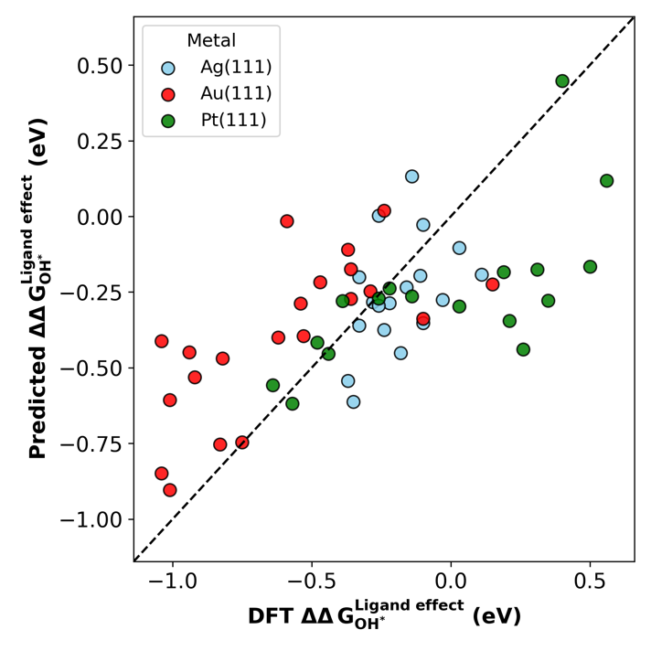

GPR 3 – ICOBI D-band strain
"ICOBI-L1", "d-band center", "Strain"
In-sample: MAE=0.053147, RMSE=0.005204, R2=0.966305
LOOCV: MAE=0.218380, RMSE=0.076228, R2=0.506442
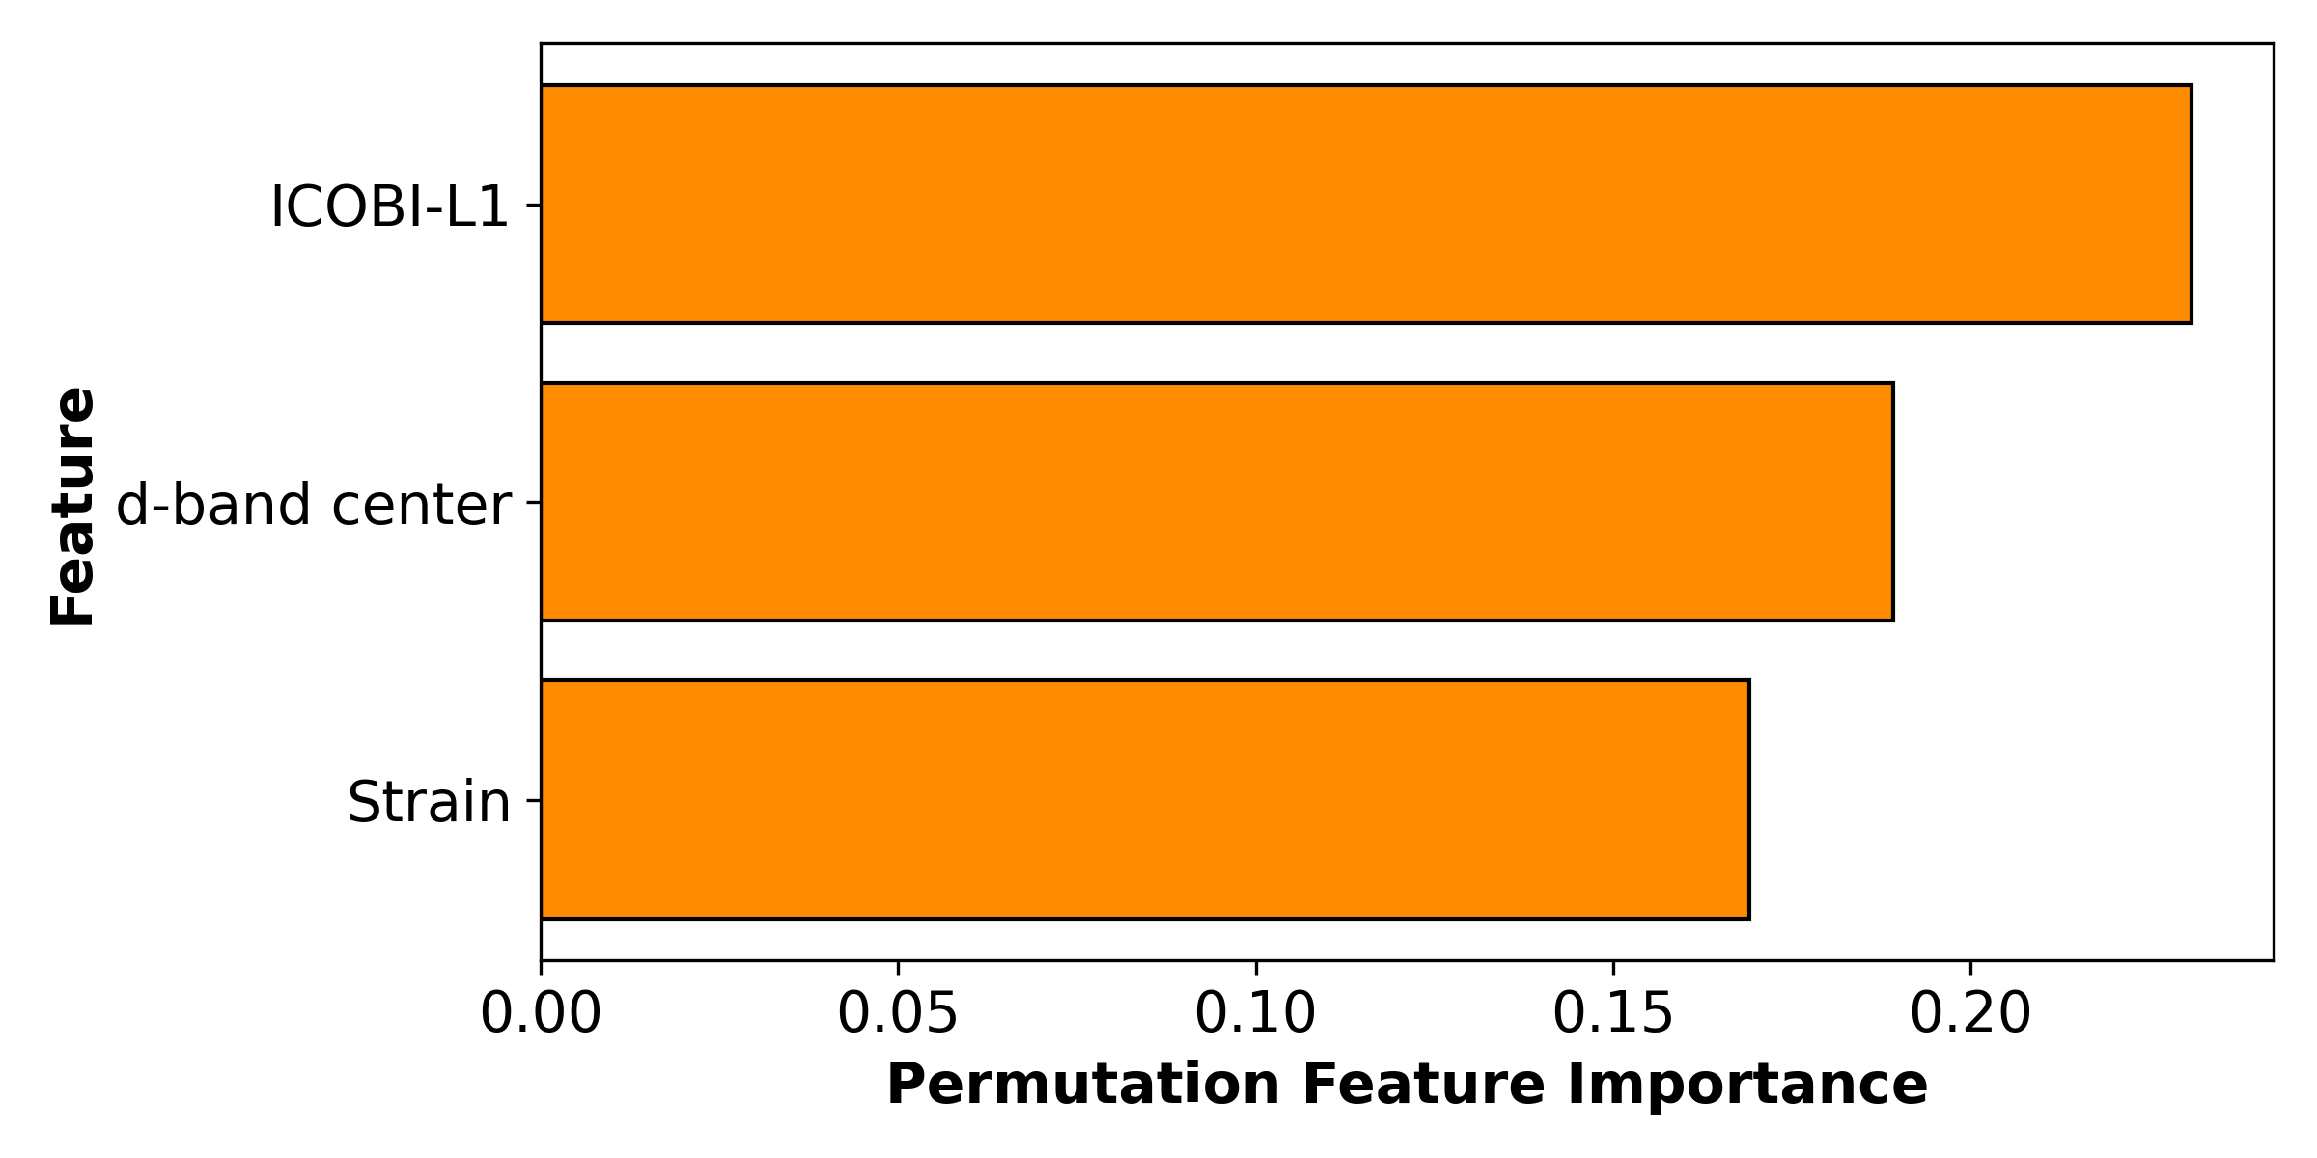
In-sample plot LOOCV plot
